**Temporary Support Workers required in Bungay**

**- Variety of hours available (mornings/afternoons/evenings) -**

**- Monday to Sunday -**

**-** **Weekday rate: £12.50 per hour -**

**- Evening/weekend rate: £13.00 per hour -**

**- 3 month position* -**

**Closing Date: 13 January 2023**

**Job description**

*Listed below are details of the purpose of the job and what tasks are involved. It is important and advisable*

*to refer to this when submitting your application for the post.*

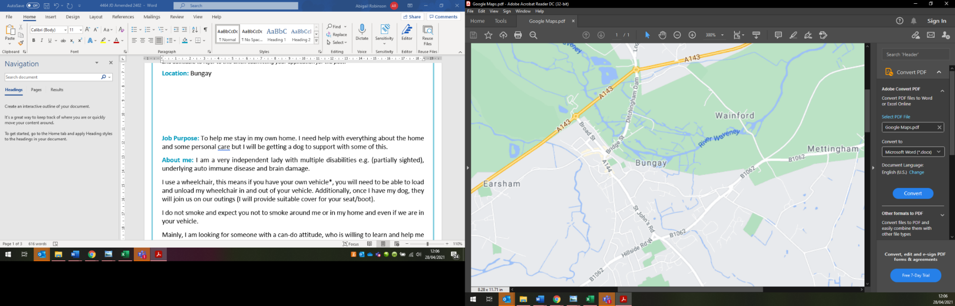**Location:** Bungay

**Job Purpose:** To help me in my own home. I need help with everything about the home and personal care.

**About me:** I am an independent lady with multiple disabilities e.g. partially sighted, underlying auto immune disease and brain damage.

I use a wheelchair, you will need to be able to load and unload my wheelchair in and out of your vehicle. Additionally, I plan to have an assistance dog. Once I have my dog, it will join us on our outings (I will provide suitable cover for your seat/boot).

I do not smoke and expect you not to smoke around me or in my home and even if we are in your vehicle.

Mainly, I am looking for someone with a can-do attitude, who is willing to learn and help me to live my life to the fullest. I will teach you how to use all my equipment safely.

**Main Duties and Responsibilities:**

*Although this job description is correct at present, it may change from time to time after negotiation with the post holder.*

* Cooking/Reheating food
* Medication
* Domestic tasks e.g. making my bed, light household cleaning, preparing food and drink daily
* Help me to prepare to go out/putting things away once I’ve been out
* Accompanying me to go out (sometimes using community transport/your own vehicle)
* Supporting me to manage my paperwork and phone calls

**Personal Specification**

*Listed below are the skills, competencies and qualities that are essential and desirable for the post. My assessment of these, both on application and at interview, will be the main factor in determining if you are*

*successful. Please refer to these when submitting your application.*

|  |  |
| --- | --- |
| **Essential Criteria** | **Desirable** |
| 1. Can-do attitude 3. Willing to learn how my disabilities affect me 4. Able to use your initiative 5. Able to keep confidentiality 6. Team worker 7. Honest 8. Flexible 9. Driver of own vehicle (with appropriate insurance) | 1. Experience working in a similar role |

**Summary terms and conditions**

* **Job Type**: *This will initially be a temporary position of 3 months with a potential offer of permanent employment at the end of the contract.
* **Days and times of work**: There are a variety of 1-4 hour shifts available everyday (mornings/afternoons/evenings) – more specific times to be discussed at interview.
* **Pay rates**: Weekday rate: £12.50 per hour & Evening and Weekend rate: £13.00 per hour
* **Expenses**: You will be reimbursed for prior agreed expenses incurred as part of the role.
* **Annual leave**: The annual holiday entitlement for this position will be equivalent to the work which would normally be done during 5.6 consecutive weeks.
* **Sick pay**: I do not operate a private sick pay scheme but provided you meet the eligibility criteria, you may be entitled to Statutory Sick Pay (SSP).
* **Policy**: You will be required to follow our Health and Safety Policy.
* **COVID**: As a Support Worker you will have priority access to the COVID-19 vaccine and COVID-19 testing (You will be expected to conduct Lateral Flow tests).
* **Background Checks**: A satisfactory Enhanced Disclosure and Barring Service check is required for this position.

If successful, you will be required to provide details of two referees.

* **Trial Period**: This post is subject to a probationary period of 3 months.

**How to apply:** If you wish to apply for this position, please complete the enclosed/attached

application form and return to the address below.

**Online:** <https://www.suffolkindependentliving.org.uk/application-form-1>

**Email:** [suffolk@silmail.org](mailto:suffolk@silmail.org) **Telephone:** 01473 603876

**Post – Address:** SIL, IP City Centre, Unit 9, 1 Bath Street, Ipswich, Suffolk, IP2 8SD